**DETAILS FOR PERSONAL ACCIDENT INSURANCE POLICY**

|  |  |
| --- | --- |
| **Name of the Employee** | KARTHICK KUMAR M |
| **Father’s Name** | MAHALINGAM M |
| **Employee Number** | 1214953 |
| **Date of Joining** | 17-Jan-22 |
| **Designation** | Systems Engineer Trainee |
| **Date of Birth** | 18-May-98 |
| **Present Address and Phone No** | 2148 86th STREET , T.N.H.B , AVADI Chennai 8610357040 |
| **Permanent Address and Phone No** | 2148 86th STREET , T.N.H.B , AVADI Chennai 8610357040 |

**Name of the Nominee/Relationship with the Employee:**

|  |  |  |
| --- | --- | --- |
| **Name of the Nominee** | **Relationship with Employee** | **Percentage Payable** |
| MAHALINGAM M | FA | 50.00 |
| BAGYAVATHI M | MO | 50.00 |
|  |  |  |
|  |  |  |
|  |  |  |
|  |  |  |
|  |  |  |

**Name and Address of the person to be contacted in case of emergency:** MAHALINGAM M , No.2148 , 86th Street , T.N.H.B , Avadi , Chennai - 600054. PH – 9283238577.

**Place:** CHENNAI 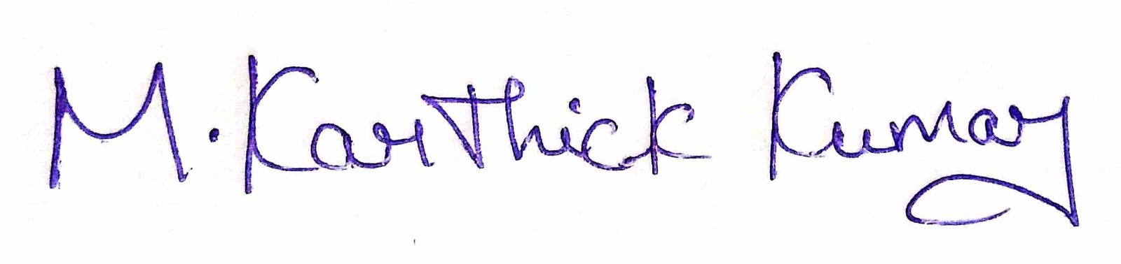  
 **Signature of the Employee**

**Date: 0**6/02/2022